* In Step 5, I input the same integer value of 15 for the people who prefer being at school in person and the people who would rather do school from home. Although the percentages for both categories were 50%, the console determined that “More students like doing school from home than being at school in person, which is an incorrect statement as an equal amount of students like doing school from home than being at school in person. Another input that produced a nonsensical output was when I input 40 for students surveyed, 30 for students who chose being at school in person, and 20 for students who chose doing school from home. This led to the output that 75% of students preferred in person schooling while 50% of students preferred schooling from home. This is nonsensical because the percentages add up to 125% suggesting that there were more students voting than there actually were.
* In the logic_error.cpp program, I switched around the outputs for the if, else statement so that 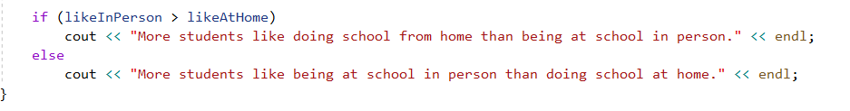

This is logically wrong because the if, else statement is reversed. If likeInPerson is greater than likeAtHome, then the program should output a statement that has to do with more students liking doing school in person than doing school from home. And vice versa.

* In the compile_error.cpp program, the first compiling error reported that it expected an identifier in line 9 because I added quotations around the integer variable “numberSurveyed” creating undefined identifiers in line 14 when the actual variable ‘numberSurveyed’ was called. 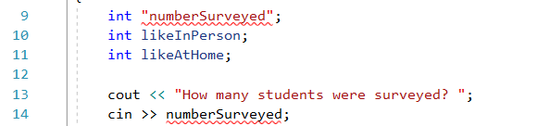

The second compiling error reported that it expected a “(“ on line 30 because I removed the parentheses required around the initial input of the if section in the if/else statement.

